**CSSE3101 – ADVANCED WEB TECHNOLOGIES**

**ACTIVITY 1 – JAVASCRIPT**

Implement the following instructions using the JavaScript Document Object Model.

1. Make a new file: **js.html**. Design the page as below.

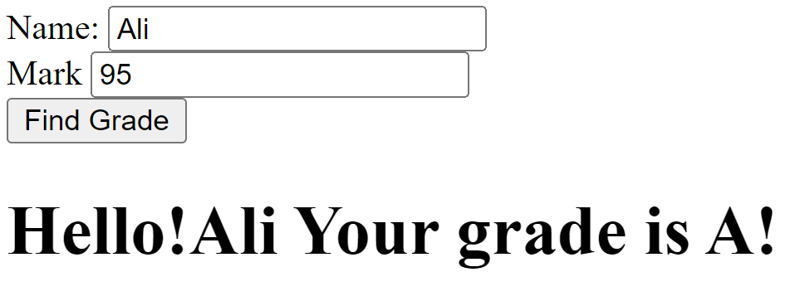

1. Implement the following functions:
   1. findGrade()
      1. Function description - Check if the student passed or failed, based on the passing mark. Display “Passed” or “Failed” as result. Check if the passing mark and the student mark has values, if not display alert(‘Input mark’).
      2. Parameter - student mark
      3. Function invocation – when user clicks the check button.
   2. validateMark()
      1. Function description - Check if the mark inputted is valid(0 to 100 only). Display an alert message (‘Mark not valid’) if the mark is not within the correct values.
      2. Parameter- mark
      3. Function invocation – when user changes the value of the text box
   3. changeColor()
      1. Function description- Change the color of the result text, blue = Passed, red = Failed.
      2. Parameter- id
      3. Function invocation – when user mouse overs on the result text.